Nuclear asset management criteria 2025

Table of contents

1. INTRODUCTION ……………………………………………………………………..……..……………………… 3

2. NATURGY’S NUCLEAR ASSETS ………………………..…………………...……………………..….... 4

3. POLICIES …………………………….………………………………………………………………………...………. 5
3.1. NUCLEAR SAFETY AND RADIATION PROTECTION ………...………….................. 5
3.2. RADIOACTIVE WASTE AND SPENT FUEL ………………….…………………................. 6

4. MANAGEMENT SYSTEMS ………………….….…………………………………………………………….. 8
4.1. REGULATIONS ..…………………………………………………………………................................ 8
4.2. GENERAL SYSTEMS ….…………………………………………………..…….............................. 8
4.3. SPECIFIC SYSTEMS …………..………………………………………………............................. 10
4.3.1. SPECIFIC SYSTEMS FOR NUCLEAR SAFETY AND RADIATION PROTECTION ….……………..…………………………………………………………………………….. 10
4.3.2. SPECIFIC RADIOACTIVE WASTE AND SPENT FUEL SYSTEMS …..… 14

5. RESULTS ……………………...……………………………………………………………………………………… 17
5.1. NUCLEAR SAFETY AND RADIATION PROTECTION INDICATORS …………. 17
5.2. RADIOACTIVE WASTE AND SPENT FUEL MANAGEMENT INDICATORS . 24

- INTRODUCTION

In its code of ethics, Naturgy, the leading company in the integrated gas and electricity market in Spain and Latin America and with a major presence in Europe, declares its firm commitment to the development of policies, procedures and tools to ensure that its activities are carried on in accordance with the laws, regulations, rules, procedures and standards, both internal and external, applicable to all operational aspects.

The Naturgy Group understands corporate responsibility as the development of actions to establish relationships based on trust, which are stable, sound and of mutual benefit to their stakeholders. The right relationship with the environment constitutes a priority objective for the company; it is essential for generating value, while watching out for the long-term sustainability of the company and helping to give a competitive edge.

Furthermore, in its Corporate Responsibility Policy, Naturgy has established that the priority objective of the company, in its relations with society, should go beyond merely covering its energy needs.

Based on sound and direct dialogue with its stakeholders, Naturgy seeks to fulfil expectations by contributing to sustainable global growth through an Environmental Policy committed to people and the environment.

Following this policy of fomenting the transparency of communications regarding the environment, Naturgy aims to complete the information posted on its website concerning the management of its nuclear assets by including the following content:

- A section on Policies where the company’s strategies are established and where the company’s guidelines and priority targets on Nuclear Safety, Radiation Protection and Waste Management are defined.
- A section on Management Systems which describes the processes, tools and practices the organisation has implemented to carry out the policies.
- A section on Reporting which includes a set of indicators to measure the efficiency of the processes implemented in relation to the targets established.

Electricity production at nuclear power plants is a highly regulated business. There are a large number of international and domestic organisations working together with the operators to define and implement effective management models, in order to make this type of energy production a benchmark in terms of safety, reliability and respect for the people and environment.

Naturgy is fully committed to these goals and, consequently, takes part in these forums. Its working practices meet the most demanding standards in the sector worldwide. Naturgy has actively generated nuclear energy since 1968 and was the first operator of a nuclear power plant in Spain.

Naturgy plays a direct or indirect part, through UNESA - the coordinator organisation of Spanish nuclear operators - in prestigious international organisations in the field of nuclear energy, such as the NEI (Nuclear Energy Institute), WANO (World Association of Nuclear Operators), EPRI (Electric Power Research Institute), etc. It also very actively participates in various domestic forums linked with nuclear research and development.

- NATURGY’S NUCLEAR ASSETS

Naturgy has experience as a nuclear operator since 1968 since the commissioning and operation of the José Cabrera nuclear power plant.

Naturgy is one of the companies owning the Almaraz and Trillo nuclear power plants. In November 1999, the Economic Interest Grouping called Centrales Nucleares Almaraz-Trillo, A.I.E. (CNAT) was created for the integrated operation, management, and administration of both plants, maintaining its ownership interests in each of them unchanged.

Naturgy's shareholdings in the Almaraz and Trillo nuclear power plants are shown below:

UNIT THERMAL POWER (MWt) SHARE (%)
Trillo 3,010 34.5
Almaraz I 2,947 11.292
Almaraz II 2,947 11.292

In addition, Naturgy is the owner (100%) of the site of the José Cabrera nuclear power plant, which was in commercial operation from 1968 to 2006 with excellent results in Nuclear Safety, Radiation Protection and Radioactive Waste Management. In February 2010, the installation has been transferred to ENRESA, a Spanish public company which is decommissioning the facilities in accordance with Spanish legislation.
- POLICIES

  - NUCLEAR SAFETY AND RADIATION PROTECTION

Excellence in the operation of nuclear assets is achieved through an attitude whereby employees should always work to ensure that electricity is produced under optimum standards of safety. No other considerations should compromise the safety of a power plant. This requires an appropriate “Safety Culture” so that safety-related issues are always addressed according to their importance.

Safety shall be understood in its broadest sense and shall cover aspects such as operational safety, radiation protection, people and environment protection, workers health and safety, facilities security, risk and safety assessment and continuous training.

- Operational Safety:

The application of both internal and external operational experience will be used to minimise possible events and incidents, including unplanned plant shutdowns. It shall also be ensured that the design bases and technical specifications of the equipment are respected and that predictive measures are developed to anticipate possible failures. This, along with efficient maintenance programmes, helps to enhance the reliability of the facilities.

- Radiation Protection:

The ALARA (as low as reasonably achievable) principle is applied, ensuring that power plants are operated in such a way that the number of people exposed to radiation and the likelihood of potential exposures occurring are reduced to a minimum. In addition, a priority target is to encourage the reduction of individual and collective doses resulting from these exposures, at both public and employee level, beyond the limits established in the Regulation on Health Protection against Radiation. The application of the ALARA principle contributes to minimising individual doses, the number of people exposed, and the frequency of occurrence of potential exposures. This is achieved, among others, with adequate planning, resource allocation and optimisation of operations.

- Environmental Policy:

There is a commitment to operate the facilities while strictly respecting environmental legislation, and predicting, controlling and minimising any environmental impacts which might stem from operating the power plants. The amount of emissions and radioactive waste generated is reduced as far as possible, implementing and keeping up-to-date a standardised treatment and management system.

- Workers Health and Safety:

One of Naturgy’s fundamental goals is the ongoing improvement of working conditions and quality of work life of all its employees. Management believes that workplace health and safety is essential to the safe and reliable operation of power plants. Consequently, the company undertakes to improve the culture of prevention in its work centres and involve every level of the organisation in this commitment.

- Security:

Protection against possible undesired external attacks is of great importance to nuclear power plants. Naturgy aims to achieve excellence on this field, through the implementation of the best practices and technologies available in the market. All of this is done following the principle of confidentiality required to guarantee that they fulfil the purpose for which they were designed.

- Risks and Safety Assessment:

Potential risks are identified and assessed through safety evaluations of all its processes, and actions are proposed to prevent weaknesses before they affect safety.

Special attention is paid in the assessment of major external hazards (earthquakes, floods, hurricanes, etc.) at the plant site. These hazards were taken into account in the phase of choosing the site for a new nuclear power plant.

In addition, structures, systems and equipment have been designed with seismic and environmental qualifications, in order to minimise the effect on nuclear safety of a hypothetical event. To monitor risk trends, the Nuclear Power Plants owned by Naturgy have specific tools like Meteorological Towers and Seismic Monitoring Systems, to detect any change in the plant site characteristics, and anticipate possible future events.

- Training:

Likewise, training is a key factor in the management of nuclear assets, thus enabling the skills of its staff to be developed and improved on an ongoing basis.

In order to meet the targets mentioned above, Naturgy conveys to its employees the idea of “Continuous Improvement” as a guarantee of “Safety” at its nuclear power plants. Its internal communication channels motivate excellence in the conduct of its employees, instilling such values as:

- Interest in learning.

- Teamwork and communication.

- Proactivity and a questioning attitude.

- Responsibility and leadership.

  - RADIOACTIVE WASTE AND SPENT FUEL

One of the aims of Naturgy’s Environmental Policy is to control and reduce as much as possible the production of waste at its facilities, including radioactive waste and spent fuel.

To this end, the company participates in forums as part of the ownership of the plants so that the waste management processes incorporate the latest advances in science and technology, in order to minimize the generation of waste at source and improve its treatment and temporary or permanent storage.

The management of the radioactive waste generated, as well as dismantling, is the responsibility of ENRESA (the Spanish radioactive waste management agency). This situation is attributed to Article 38 B of the Spanish Nuclear Energy Act, Law 25/1964 of 29 April (in the wording given to this precept by Law 11/2009 of 26 October) under the heading ‘Management of Radioactive Waste’, which states the following: ‘The management of radioactive waste, including spent nuclear fuel, and the dismantling and shut down of nuclear facilities is an essential public service which is reserved for the State, in accordance with Article 128.2 of the Constitution of Spain. Empresa Nacional de Residuos Activos, S.A. (ENRESA) is entrusted with this public service, in accordance with the General Radioactive Waste Plan approved by the Government. To this end, ENRESA is established as a resource and technical service of the Administration, performing the duties entrusted to the company by the Government. Likewise, the system for financing the costs of this management is also established.’

- Operational Radioactive Waste and Spent Fuel:

Radioactive waste from operations and spent fuel at Spanish nuclear plants are managed in accordance with a set of general criteria set out in the Radioactive Waste General Plan, a document prepared by ENRESA.

Naturgy abides by these criteria and bases its policies on the following fundamental principles:

- Nuclear facilities are aware of their social responsibility as producers of potentially harmful wastes and ensure that these wastes are safely managed from its source until their delivery to ENRESA.
- Protection of the public and workers against radiation must be ensured during every stage of the radioactive waste management process.
- The traceability of the waste and of waste management operations must be ensured.
- The waste flow and the evolution of its physical, chemical and radiological properties must be known and controlled.
- As far as is reasonably possible from a technical and economic viewpoint, the amount of waste produced and removed from the plant must be reduced to a minimum and the waste material must be segregated and recycled.

These principles will apply to all radioactive waste generated from the plant and to spent fuel.

In the case of fuel, management begins from the moment it is received at the facility. Maintaining the integrity of the fuel has always been a priority at the plants in which Naturgy has a stake. In addition, it supports initiatives to reduce the number of failures to zero, thus minimizing the generation of waste and the impact on people and the environment.

- Decommissioning Radioactive Waste:

The decommissioning and closure phase of nuclear facilities in Spain is currently the responsibility of ENRESA, to which ownership of the facility is transferred once it has ceased to operate. This company manages the waste generated during the decommissioning phase.

However, there is a commitment on the part of Naturgy to promote behaviour patterns in its facilities that lead to minimizing the waste that will be generated during dismantling.

- MANAGEMENT SYSTEMS

  - REGULATIONS

The Almaraz and Trillo nuclear power plants are operated in accordance with all current legislation in Spain applicable to their activities, whether European Directives, Laws, or Royal Decrees.

In turn, the Spanish regulator - the Nuclear Safety Council (CSN) - issues standards or instructions complementary to that legislation, which are of a binding nature for producers.

Taking into account both factors, each facility produces its Official Operation Documentation, by virtue of which the competent authorities periodically grant and renew the operating license. The Official Operation Documents are the following: Safety Analysis Report, Operational Regulation, Technical Specifications, Internal Emergency Plan, Quality Assurance Manual, Radiation Protection Manual, Radioactive Waste and Spent Fuel Management Plan, and Physical Protection Plan.

More detailed information on management systems and nuclear regulations in Spain can be found on the website of the Almaraz-Trillo Nuclear Power Plants (www.cnat.es) and the CSN website (www.csn.es).

  - GENERAL SYSTEMS

Trillo and Almaraz nuclear power plants have an Integrated Management System whose purpose is to ensure a safe, reliable and effective management of all the plant’s activities, by means of a global or systemic view of the various specific management systems.

This Integrated Management System meets the requirements of management regulation GS-R-3 (Safety Requirements for the Management System for Facilities and Activities) of the International Atomic Energy Agency (IAEA). It also meets the requirements provided for by Safety Instruction IS-19 of the Spanish Nuclear Safety Council.

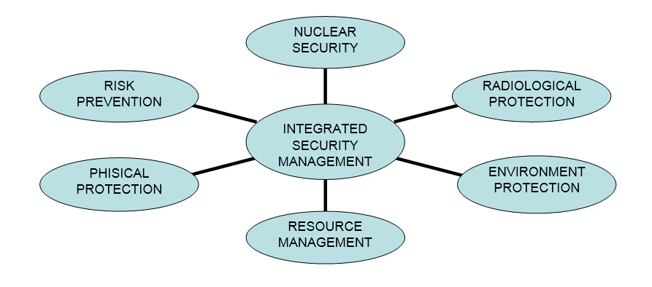

To manage their processes, the Almaraz and Trillo nuclear power plants take as their reference an international model of nuclear processes; the NEI model, which enables optimal comparison analysis among the plants around the world.

All operating, support and management processes are managed from their inception and during their execution until it is proven that the processes are functioning correctly and the improvement measures designed to optimise them are implemented, in accordance with PDCA or Deming improvement cycle.

One of the elements that most contributes to the safety and efficiency of the Almaraz and Trillo nuclear power plants is the capacity of the organisation to learn. Their learning system strives to leverage all available intellectual capacity, knowledge, and experience, whether internal or external, and to learn from it in order to improve continually in the pursuit of the collective and individual goals of the organisation as a whole.

The Quality Management System of Almaraz-Trillo is certified by AENOR (Spanish Association for Standardisation and Certification) under UNE EN ISO 9001 standard and also satisfies the requirements of the IAEA management standard GS-R-3 (Safety Requirements for the Management System for Facilities and Activities).

In 2024, AENOR carried out a certification renewal audit with satisfactory results. It also complies with the benchmark quality standard in the nuclear sector, UNE 73401 on Quality Assurance at nuclear facilities, which is the basis of the Quality Assurance Manual, the requirements of which are permanently inspected by the Nuclear Safety Council (CSN).

The quality assurance programmes of Almaraz and Trillo nuclear power plants ensure that these plants operate optimally in terms of safety and availability. These programmes are contained in manuals for each plant, which establish the criteria for assuring the quality of all the operational activities of the plants and meet prevailing domestic and international nuclear quality regulations.

Almaraz and Trillo nuclear power plants have annual training plans covering staff with an operation license and the rest of the staff, adapted to the needs of each worker and position. These plans also apply to staff of contracting companies and include retraining requirements of its Plant’s staff and initial training for new workers. The more relevant issues that are included in the training plan are:

- Plant System Design and Technology,
- Internal and External Operating Experience,
- Physical protection and Nuclear Safety,
- Radiation Protection,
- Fire Protection,
- Emergency Plan,
- Waste Management,
- Environmental Management,
- Occupational health and safety,
- Management skills.

The training plan is designed taking into account the background of the worker and the training needs of the job.

Training is key to continuously improving the levels of safety, quality, efficiency, and competitiveness of the Almaraz and Trillo plants. In this respect, training plans are implemented with the aim of developing the skills of staff, keeping them up-to-date and maintaining a constant attitude of learning and self-improvement in a context of knowledge and technologies that are constantly and profoundly evolving.

The Almaraz and Trillo plants are characterised by their highly qualified and experienced workforce.

Almaraz-Trillo has been certified by AENOR INTERNACIONAL S.A.U. in accordance with the ISO-10.667-2:2011 standard on the provision of assessment services: Procedures and methods for the assessment of people in working and organisational environments.

The Environmental Policy at Almaraz and Trillo nuclear power plants is implemented through an Environmental Management System set out in the corresponding manual, in accordance with and certified by international standard ISO-14.001, renewed in September 2023. One of the most important sections of this standard deals with the measurement and evaluation of the trends in environmental parameters and their possible impact on the environment.

  - SPECIFIC SYSTEMS

    - SPECIFIC SYSTEMS FOR NUCLEAR SAFETY AND RADIATION PROTECTION.

To meet the objectives Naturgy has set itself in the field of nuclear safety and radiation protection, the company has supported the implementation of the following specific systems or tools at the Almaraz and Trillo nuclear power plants:

- Operational Safety:

Preventive maintenance, inspection and design modifications programmes have been elaborated in which all the related activities to be carried out at the plant are planned and scheduled. The design of these programmes considers the surveillance requirements of the equipment in accordance with their technical specifications and the results of reliability studies. These latter studies receive feedback from other specific tools such as the maintenance rule or probabilistic safety analysis (PSA).

Probabilistic safety analysis (PSA) is a very powerful tool for assessing operating risks, evaluating the plant's response to potential internal and external incidents (earthquakes, floods, etc.). This is performed in accordance with the safety guides of the CSN, from the U.S. Nuclear Regulatory Commission (NRC) (for example, NUREG CR 2815 and 2300), and EPRI guidelines.

Furthermore, the nuclear power plants owned by Naturgy make an important volume of investments in technological improvements and modifications of the facilities through a multiyear Operational Plan of the nuclear power plants, updated each year.

There is also an Operating Experience Programme in place at the facilities, whereby all the events and incidents occurring at the plant are analysed, including unplanned plant shutdowns, as well as the operating experiences of other plants which may be applicable to our plants. After an event occurs, a root cause analysis is made, to take the necessary corrective measures to prevent the same or similar event happening again in the future. This analysis is performed using internationally recognised methodologies.

Fire risk is an outstanding operational risk, due to its possible implications. This is managed through specific programmes at each plant, documented in the Manual for Protection against Fires.

To prevent external risks, Almaraz and Trillo power plants monitor parameters that could warn of major natural hazards. Both plants have installed a seismic surveillance system, whose maintenance and operation are under technical specifications. Each plant also has a Meteorological Tower which has recorded temperature, rain, and wind data, from the beginning of construction and plant operation.

All systems described above are designed and managed to prevent the occurrence incidents. Prevention is proactive because the equipment condition of major equipment is monitored and maintained and the operating experience, internal and external, is considered.

Although there is a wide range of systems and procedures to prevent the occurrence of accidents, Nuclear Power Plants have Internal Emergency Plans for the control of radiological risks in case a hypothetical accident occurs.

International assessments have also been carried out to determine the organisation’s degree of excellence. These include the Peer Review of WANO (World Association of Nuclear Operators), an independent assessment by a group of international experts. In December 2021, the CNAT Corporate Peer Review was carried out. In March 2022, the World Association of Nuclear Operators (WANO), after the results obtained in the Peer Review carried out at the Trillo plant, placed this facility at WANO level 1. In 2024, the results of the 2022 Peer Review have been monitored at CN Trillo. Following the peer review carried out in February 2025, the World Association of Nuclear Power Plant Operators (WANO) has once again awarded its highest rating to Almaraz (WANO 1).

Likewise, in November 2019, the Follow-up of the OSART mission carried out in 2018 by the International Atomic Energy Agency (IAEA) was carried out at the Almaraz NPP. During OSART missions, a group of IAEA experts carry out in-depth reviews of the operational safety performance of the nuclear power plant (Operational Safety Review Teams), analysing the factors affecting safety management and personnel performance. The results obtained from monitoring the recommendations proposed in 2018 have been extremely positive, with the Almaraz NPP performing above the international average.

- Radiation Protection:

The practices followed at Trillo and Almaraz nuclear power plants to apply the ALARA principle to the protection of the public and staff against radiation is described in the plants’ Radiation Protection Manuals and, more specifically, in their Dose Minimisation Plan.

At each facility there is a Radiological Surveillance and Monitoring System for Areas and Processes, under which radiation risks are determined and works and activities planned.

Access to areas of radiological risk is controlled by the Radiological Protection Service (RPS) of each plant, authorised by the CSN. The RPS determines the optimal protection measures for each job to minimise exposure to radiation (maximum exposure time, required physical shielding, required personal protection systems, etc.). This same service records and controls the staff’s personal dosimetry, to ensure that the objectives of the Dose Minimisation Plan are met.

Dosimeters have been assigned to employees to have an updated record of the individual dose received. Depending on the evolution of doses, the RPS could determine to change the work plan for an employee, after checking the exposure level reached in previous activities.

During normal operation, the radiological protection of the public is achieved in two ways:

- Treatment, monitoring and management of liquid and gaseous effluents.

- Monitoring programme and analysis of ambient samples in the vicinity of the plant.

These aspects are dealt with in greater detail in the section on environmental policy.

The above systems protect employees and the public against radiation. Thus, dose limits are not expected to be exceeded in normal operation or not, even in the case of design base accidents of the Nuclear Power Plant. Despite this, if an emergency arises on site, each of the nuclear plants owned by Naturgy has an Internal Emergency Plan, approved by the Ministry, describing what actions should be taken, depending on the seriousness of the situation.

The Internal Emergency Plan contains provisions for organising and setting roles and functions, managing the facility to minimise radiation exposures and damages. In the most critical case, the measures included evacuation.

This plan is evaluated continuously by the licensees and regulatory authorities and its results are monitored in the SISC System; the Spanish management system similar to the ROP (Reactor Oversight Process) in the USA.

The Internal Emergency Plan, together with the corresponding Provincial Emergency Plan (which is activated by the authorities) make up the Integrated Emergency Plan. The purpose of this integrated plan is to respond to situations jeopardising the public, the staff, or the environment by mitigating any radiological or other consequences that might ensue during a hypothetical accident.

- Environmental Policy:

The Environmental Management Programmes of the Trillo and Almaraz nuclear power plants are integrated in the Organisation’s Environmental Management System, which, as has been mentioned in section 4.2 General Systems, is certified under international standard ISO-14.001.

The environmental aspects (defined by the standard as “elements of activity which can interact with the environment”) identified at the nuclear power plants owned by Naturgy can be broken down into the following categories: atmospheric emissions, generation of radioactive waste, generation of hazardous and non-hazardous waste, liquid and gaseous effluent-based radioactive dose, dose measured in environmental radiological surveillance programmes, physical-chemical discharges, thermal discharges and consumption of resources.

Of these, the following aspects are specific to nuclear facilities:

- Generation of radioactive waste,
- Dose due to radioactive liquid and gaseous effluents
- Measured dose in environmental radiological surveillance programmes.

The specific systems implemented at the plants owned by Naturgy to reduce the impact on people and the environment of the generation of radioactive waste is dealt with in section 4.3.2 Specific Radioactive Waste and Spent Fuel Systems.

To minimise the impact of liquid and gaseous effluents on people and the environment, the Almaraz and Trillo plants have Liquid and Gaseous Waste Treatment Systems which halt the activity of the fluids before they are released into the environment.

An Effluent Surveillance and Sampling System has also been installed at discharge points. Based on the measurements obtained and making use of the Dose Calculation Manual (DCM), the effective dose to the public is calculated, checking that the dose remains at minimal levels, always lower than those caused by natural radiation.

However, to verify experimentally the impact that radioactive effluents could have on the environment, the power plants carry out an Environmental Radiological Surveillance Programme by taking direct measurements of the radiation levels in the vicinity of the facilities and radiochemical analyses of several types of environmental samples collected from a set of sampling points.

Comprehensive surveillance is maintained over all abiotic elements and living species representative of the ecosystems associated with the natural resources in the area surrounding the power plants (airborne, terrestrial, and aquatic).

At each of the plants, over a thousand samples are collected and analysed every year, which gives an idea of the intensity of the surveillance performed.

- Health and Safety:

The way in which the nuclear power plants articulate occupational health and safety is set out in their Occupational Risk Prevention Plan. This plan establishes measures for controlling all occupational risks, not only radiological risks but conventional ones too.

Based on the basic principle that all occupational accidents can and should be avoided, the health and safety of people and the integration of Prevention at all levels of the Organisation are a priority for the Almaraz and Trillo plants. The commitment to the Health and Safety of people must be a hallmark of the Almaraz-Trillo Nuclear Power Plants, with its ultimate objective being to record and uphold ZERO accidents. For this reason, since 2018 the management of the Almaraz and Trillo plants has promoted a multi-year project to improve the preventive culture of the organisation, named the A-ZERO Plan. With this objective in mind, various lines of action have been promoted involving the entire workforce of the Almaraz and Trillo plants, with a key focus on the collaborating companies that carry out their activities at the plants.

Following the external audit carried out in 2024 by Audelco, Almaraz-Trillo Nuclear Power Plants has been recognised for its excellence in occupational risk prevention, obtaining a score of more than 81 out of 100 in the AAAR (Audelco Assessment of the Audit Result) assessment, a result that is above the sector average.

- Security:

The Nuclear Power Plants owned by Naturgy have security plans and security systems to safeguard their facilities from possible intrusion by third parties. Their design, based on the identification of potential dangers and the placement of active and passive measures to prevent damage, is protected by a principle of confidentiality.

Trillo and Almaraz Nuclear Power Plants work together with the other Spanish plants to define common approaches in improving security, keeping their security systems up to date with the identification of new hazards that arise at international level, and installing best practices and the latest technology to address those risks.

The Nuclear Power Plants owned by Naturgy are also collaborating with National and International Authorities in complying with International Treaties and Obligations.

- Risk and Safety Assessment:

During the whole life of the facilities, safety assessments of various types are carried out to analyse the impact on safety by the changes that may take place in the organisation, processes, structures, systems and components of the power plant. Prior to modifying a procedure or implementing a design modification in the plant, a safety assessment is carried out to proactively manage any risks that may arise. Risks are identified and actions are taken to ensure the safety of activities.

In addition to the systematic safety assessments, periodically comprehensive safety analyses are performed to verify the correct status of the plant. Worthy of special mention among these evaluations, is the Periodic Safety Revision, which takes place at each facility in Spain every ten years, in parallel with the renewal processes for the operating license.

Safety Assessments study facility vulnerabilities to both internal and external events. For example, when a design modification is implemented, safety evaluation included seismic and meteorological risk analysis. These subjects are evaluated by the Periodic Safety Revision as well.

There are other tools to detect possible actions to improve or correct weaknesses, such as internal audits, self-assessments carried out in different areas, as well as controls from external bodies, such as inspections by the CSN, the WANO peer reviews and the missions of the International Atomic Energy Agency. Furthermore, Naturgy participates in the Nuclear Safety Oversight Committee for each of the power plants and in the independent operator audits in specific matters related to Nuclear Safety and Radiation Protection.

As an example of the proactive input in resolving weaknesses detected, it should be highlighted that nuclear power plants owned by Naturgy manage a very large number of improvement actions each year, coming from independent internal and external evaluation, as well as self-assessment and suggestions from staff. To monitor and control the implementation of these actions, each power plant has a programme, carried out through a specific management tool.

- Training:

The power plants have Training Plans for all personnel, described in section 4.2 General Systems, aimed at maintaining an attitude of continuous learning and self-improvement to keep up with the demands of a world in which knowledge and technologies are constantly changing.

    - SPECIFIC RADIOACTIVE WASTE AND SPENT FUEL SYSTEMS.

- Operational Radioactive Waste and Spent Fuel:

The methods and tools used at the nuclear power plants owned by Naturgy for managing radioactive waste are set out in their respective Radioactive Waste Management Plans.

The Waste Management Plan is a document based, in turn, on supporting studies which contain the information required to enable a detailed analysis of the waste management methods to be spent at each facility, in accordance with the aims of Safety Guideline 9.3 of the Nuclear Safety Council. The content of the supporting studies covers the following aspects:

- Current situation in terms of the generation and management of waste at the facility.

- Current situation in terms of the generation and management of spent fuel at the facility.

- Classification of the facility into waste generation areas.

- Analysis of experience and identification of possible improvements to the management of radioactive waste and spent fuel.

- Selection, justification, and implementation of new ways of managing radioactive waste and spent fuel.

To its management and subsequent storage, and considering its clearly differentiated characteristics, radioactive waste can be divided into two categories:

- Medium and low activity radioactive waste:

This type of waste arises as a result of the operation and maintenance of the plants, in the activities carried out in the controlled area. They include, on the one hand, spent coolant filtration and purification media and, on the other hand, materials from the maintenance of the installation, coveralls, and protective clothing.

Depending on the specific activity (concentration) of their radionuclides, radioactive waste may be classified as Low and Intermediate Level Waste (LILW) and Very Low-Level Waste (VLLW). All these wastes have been optimised since the beginning of operation of the Plant.At the Almaraz and Trillo power plants, very low, low and medium activity waste reduction is addressed with measures such as:

- Maintenance programmes appropriate to the systems which contain radioactive fluids (liquid and gaseous) to minimise leaks and prevent the contamination of other systems.

- Improvement in the efficiency of filters and demineralisers to reduce impurities.

- Control of materials and tools taken into contaminated areas.

- Proper segregation of materials according to their level of activity, declassifying those whose levels of activity comply with the limits established.

Low and medium activity wastes are treated at the plants themselves, to prepare them for definitive storage. Depending on its source, each type of waste has a specific treatment process.

Low and medium activity wastes, once treated, are stored temporarily inside the plants, are then periodically removed by ENRESA and taken to the agency’s facilities at El Cabril (Cordoba).

An Agreement exists indicating the service provided by ENRESA to the operators and the term of the same. A fee is established for the Spanish nuclear power plants to pay this service to ENRESA.

- High Activity Radioactive Waste: Spent Fuel

The nuclear power plants owned by Naturgy operate in 18-month cycles (Almaraz) and 12-month cycles (Trillo). At the end of each cycle, they are shut down to reload with fuel and carry out the general maintenance of the plant.

At each shut-down, a part of the fuel is extracted from the reactor and replaced with fresh fuel. The removed fuel is stored in pools which are subject to a surveillance process, similar to that which it underwent while it was in the reactor.

The Almaraz and Trillo nuclear power plants optimise comprehensive and safe management of the fuel cycle for the dual purpose of maximising the safe use of the fuel and minimising the generation of waste. This requires the design and manufacture of high quality, reliable fuel guaranteeing operation with zero leaks.

While the fuel is stored in the spent fuel pool, it undergoes a process of thermal and radioactive decay. At the facilities the spent fuel pools are located in properly protected buildings, which ensure that there is no impact on the environment.

The Trillo Plant also has an Individualised Temporary Storage (ITS), consisting of an auxiliary building in which spent fuel is stored dry in hermetically sealed air-cooled containers. In 2018, the Almaraz nuclear power plant has put into operation an outdoor IWT, in which spent fuel from the operation is stored dry in containers.

These containers have been especially designed to ensure the highest levels of safety, without any significant impact on people and the environment.

The inventory of fuel stored in the power plants is controlled by the IAEA, as the body responsible for compliance with the Non-Proliferation Treaty.

During the normal operating phase of the plant no other high level radioactive waste is generated that is not related to the aforementioned spent fuel.

- Decommissioning Radioactive Waste:

As already mentioned in the section on policies, the management of radioactive waste during the decommissioning phase of Spanish nuclear power plants is the responsibility of ENRESA. However, during the operation of the plants, several activities to reduce as much as possible the waste generated during the future decommissioning of the facilities are carried out. Some of the most important measures include:

- The deployment of physical and administrative barriers to prevent contamination from spreading and affecting initially uncontaminated structures, systems, and equipment.
- Decontamination and clean-up of systems and structures which may have been contaminated by accidental leaks during the operation of the plant.
- Appropriate recording of the radiological and operating information of the facility’s structures, systems, and equipment so that it is readily traceable during the decommissioning phase.

In addition, once the plant is definitively shut down and in accordance with ENRESA, decontamination of the systems is to take place to facilitate its decommissioning minimising the dose to workers.

Naturgy, on the basis of its shareholding, is paying the necessary provisions for decommissioning to the national fund managed by ENRESA, according to the energy generated in its plants, in accordance with the stipulations of the General Radioactive Waste Plan.
- RESULTS

The results obtained are shown below, indicating the absolute values for each reactor and the part proportional to Naturgy, the latter being calculated as averaged values considering the ownership share and power of the plants.

  - NUCLEAR SAFETY AND RADIATION PROTECTION INDICATORS

NS1: UNPLANNED AUTOMATIC SHUTDOWNS PER 7,000 H (WANO UA7)

Values per reactor

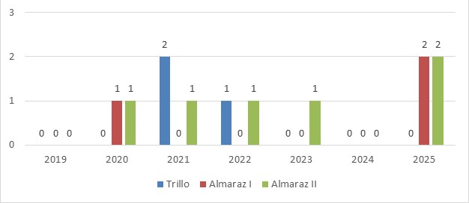

Naturgy indicator

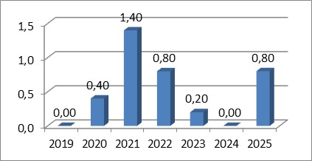
NB: Almaraz and Trillo power plants continue to take preventive actions to minimise unplanned shutdowns as have been described in Section 4.3.1. Epigraph “Operational Safety”.

NS2: NUMBER OF N0 TYPE INCIDENTS NOTIFIED ACCORDING TO ‘INES’ SCALE

Values per reactor

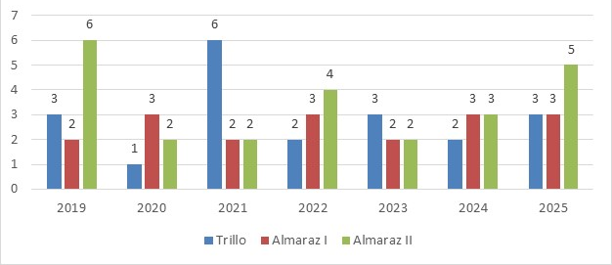

Naturgy indicator

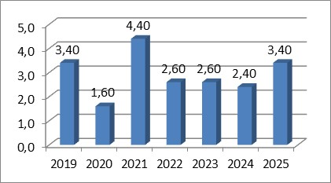
NB:The annual values are influenced by statistic fluctuations. Even if this kind of event has not had an impact on safety, weaknesses below them are identified, in order to prevent the same event or another similar event from happening in the future. Actions taken to reduce these incidents in Naturgy nuclear power plants are detailed in Section 4.3.1. Epigraph “Operational Safety”.

NS3: NUMBER OF N1 TYPE INCIDENTS NOTIFIED ACCORDING TO ‘INES’ SCALE

Values per reactor

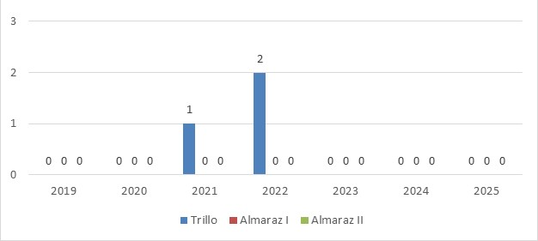

Naturgy indicator

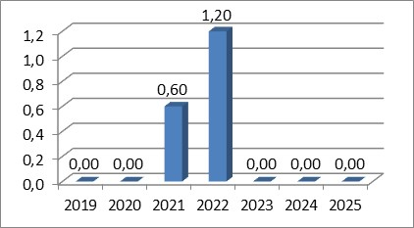

NS4: NUMBER OF N2 TYPE INCIDENTS NOTIFIED ACCORDING TO ‘INES’ SCALE

Values per reactor

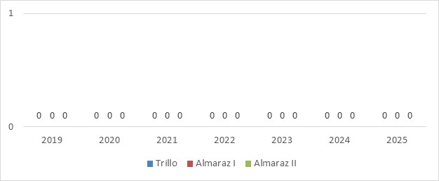

Naturgy indicator

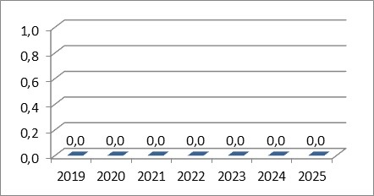

NS5: NUMBER OF N3 TYPE INCIDENTS NOTIFIED ACCORDING TO ‘INES’ SCALE

Values per reactor

Naturgy indicator

NS6: EFFECTIVE DOSE FOR PUBLIC (micro-SV)

Values per plant

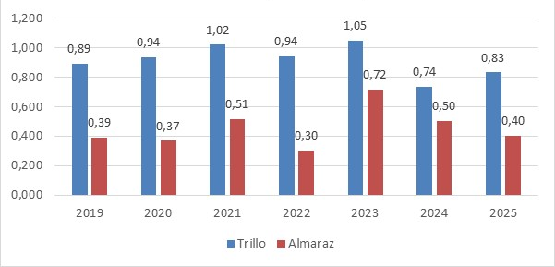

Naturgy indicator

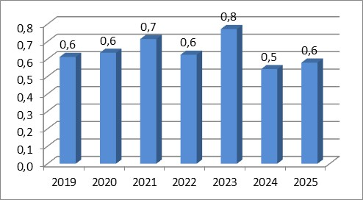
NB: Annual values are highly dependent on the number of refuelling outages within the year and are influenced by statistic fluctuations. Although, these values are a very small fraction (thousandth) of the annual limit established by legislation (1mili Sv), to maintain the downward trend, improvements have been introduced with the aim of reducing the amount of effluents generated through the optimisation of treatment processes. In 2018 there was a decrease in the reported values. This is due to the new calculation methodology required by the Nuclear Safety Council based on realistic calculations.

NS7: COLLECTIVE OPERATIONAL DOSE (Sv-PERSON)

Values per plant

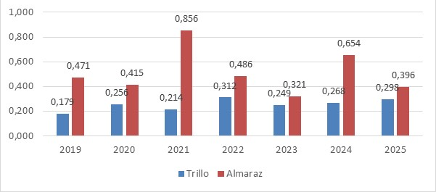

Naturgy indicator

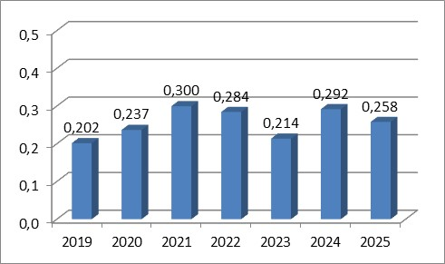

  - RADIOACTIVE WASTE AND SPENT FUEL MANAGEMENT INDICATORS

NW1: LOW AND MEDIUM ACTIVITY WASTE GENERATED AND TREATED (m3)

Values per plant

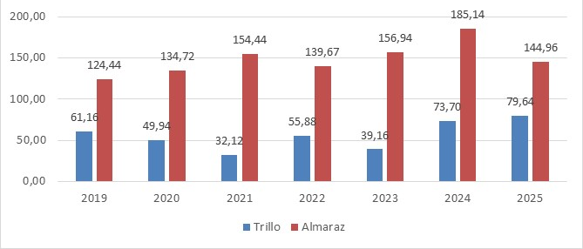

Naturgy indicator

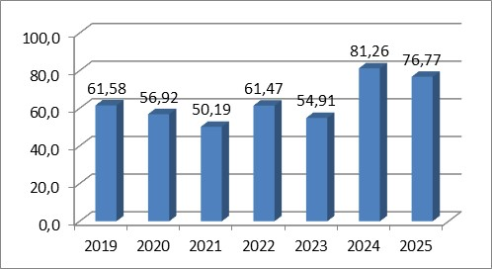
NB: Radioactive waste, depending on the specific activity (concentration) of its radionuclides, can be classified as Low and Intermediate Level Waste (LILW) or Very Low-Level Waste (VLLW). The annual values are affected by statistical fluctuations and by the number of refuelling outages, as more waste is generated during this period. Actions continue to be taken to reduce the volume of waste.

NW2: ACCUMULATED SPENT FUEL IN THE SPENT FUEL POOL (INITIAL tU)

Values per reactor

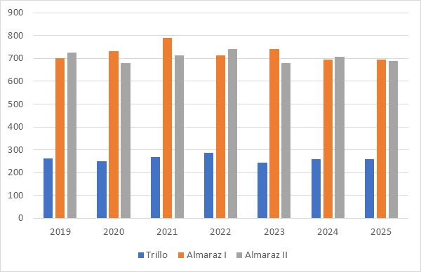

Naturgy indicator

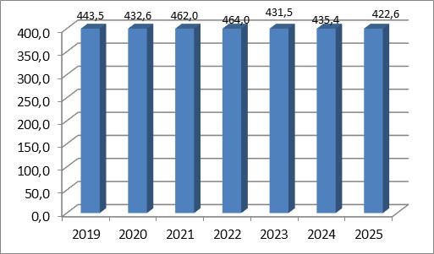
NB: The values ​​shown in the table represent the situation of the pool as of December 31 of the corresponding year. The accumulated value depends on the number of recharging stops made each year. It also depends on fuel transfers from the pool to the Individualised Temporary Storage (ITS) made during the year.

NW3: SPENT FUEL ACCUMULATED IN ITS (INITIAL tU)

Values per reactor

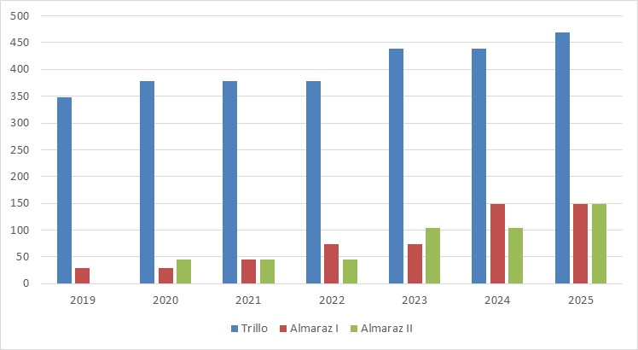

Naturgy indicator

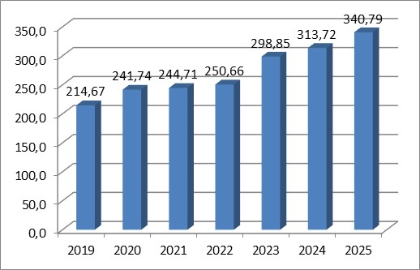
NB: The situation shown is December 31. Cumulative values increase every year, due to transference of spent fuel from pool. In 2018 the Almaraz ITS began operating, loading a spent fuel container over the course of the year.
NW4 NEW FUEL ACCUMULATED IN STORAGE (INITIAL tU)

Values per reactor

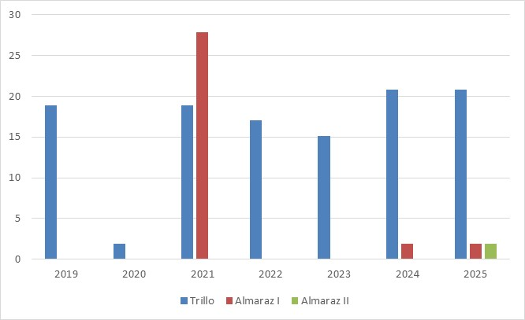

Naturgy indicator

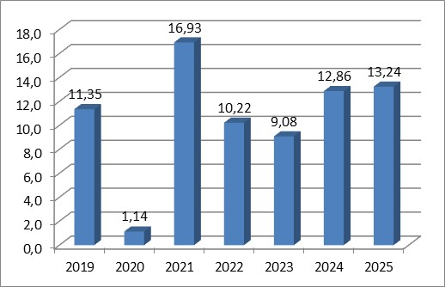
NB: The table above shows the amount of new fuel at the plant as of 31 December of the corresponding year. The annual values fluctuate because they are highly dependent on the number of refuelling stops made in the year and the date on which the new fuel is received at the plant.

NW5 NEW FUEL INCORPORATED (INITIAL tU)

Values per reactor

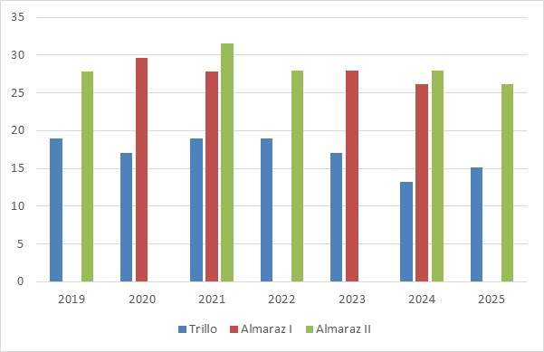

Naturgy indicator

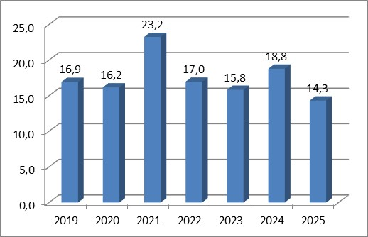
NB: The values show the amount of new fuel that has been added to the reactor during the year. This quantity fluctuates as it depends on whether there has been refuelling during the year and on the number of fuel elements incorporated in the reactor.

NW6: DECOMMISSIONING WASTE

As indicated above, Naturgy owned 100% of the José Cabrera nuclear power plant (permanently shut down in 2006). The dismantling work was initiated by ENRESA in 2010 and continues to be carried out today. ENRESA estimates that throughout the dismantling project of the José Cabrera NPP approximately 141,000 tonnes of material will be managed. Approximately between 10% and 15% of this material will be managed as radioactive waste and the rest as conventional waste.

Below is the information provided by the approved version of the 7th PGRR of December 27th, 2023, in relation to the volume of waste generated at NPP. José Cabrera, these are volumes of wastes generated in dismantling as of 31st December 2022 of very low, low and intermediate level (table 3 and 4) are 12,931m3. Special wastes (table 6) 31 m3. Spent fuel 100 tonnes of uranium. With a forecast generation from 1 January 2022 of very low-level waste of 2,500 m3.

Enresa - Dismantling of the José Cabrera NPP

